

NSW Education Standards Authority

Annual Report

2019

Reporting on the 2018 Calendar Year

Tweed Valley Adventist College

Owned and Operated by

Seventh-day Adventist Schools
(NNSW) Ltd

A message from key school bodies – (School Advisory Council)
  - College Advisory Council Chairman Statement

In many ways 2018 was a very positive year at TVAC. Adventist Schools Australia have commissioned Insight SRC to survey students teachers and parents from every school to identify the contributing factors to the health of the school.

It was with great interest that we note very positive progress and achievement in a number of important areas of school life.

Table 1

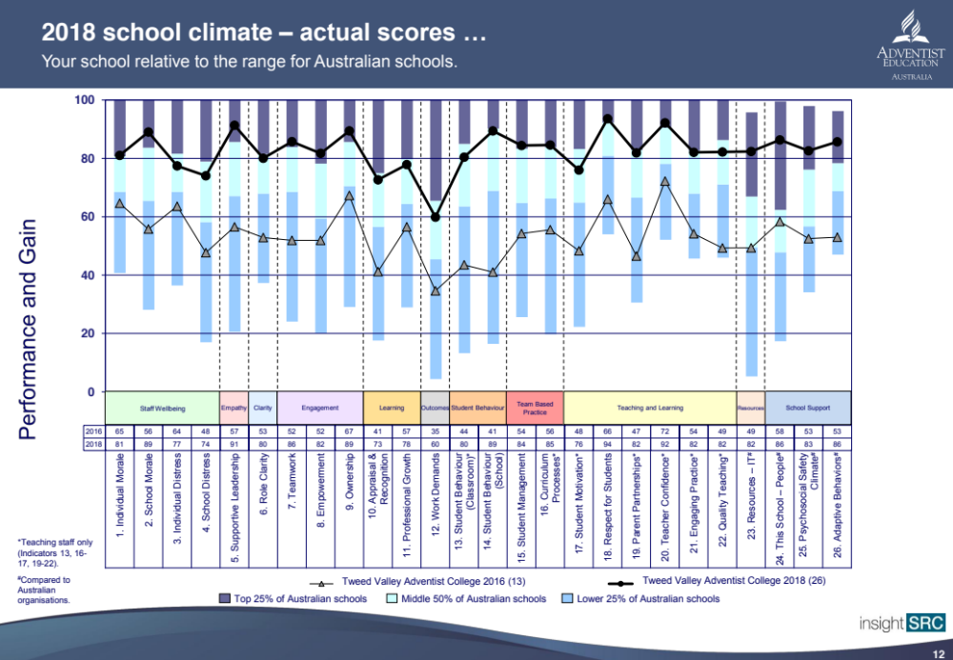

This table shows a strong improvement in the area of school culture. We acknowledge the great effort of teachers, chaplains, staff, students and parents for the improvement.

Table 2

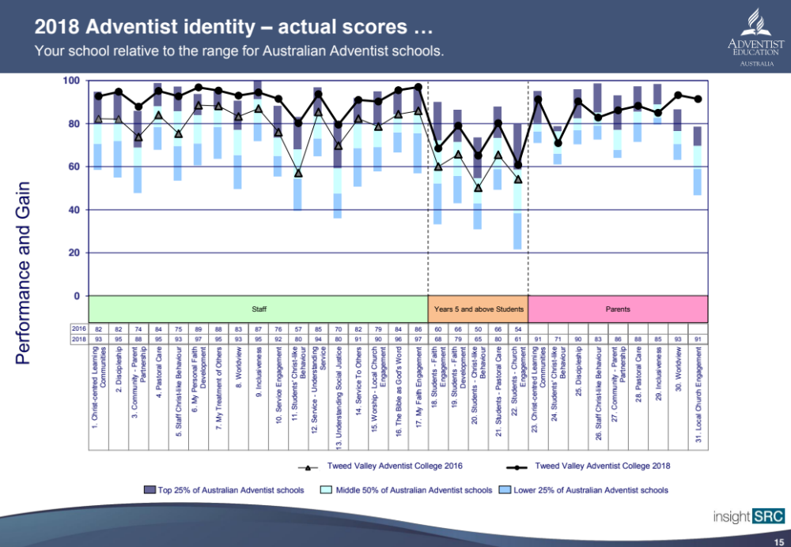

This table shows improvement on an already strong base. The Council take great satisfaction in this result and commend the staff for providing such a positive spiritual environment for the students.

Table 3
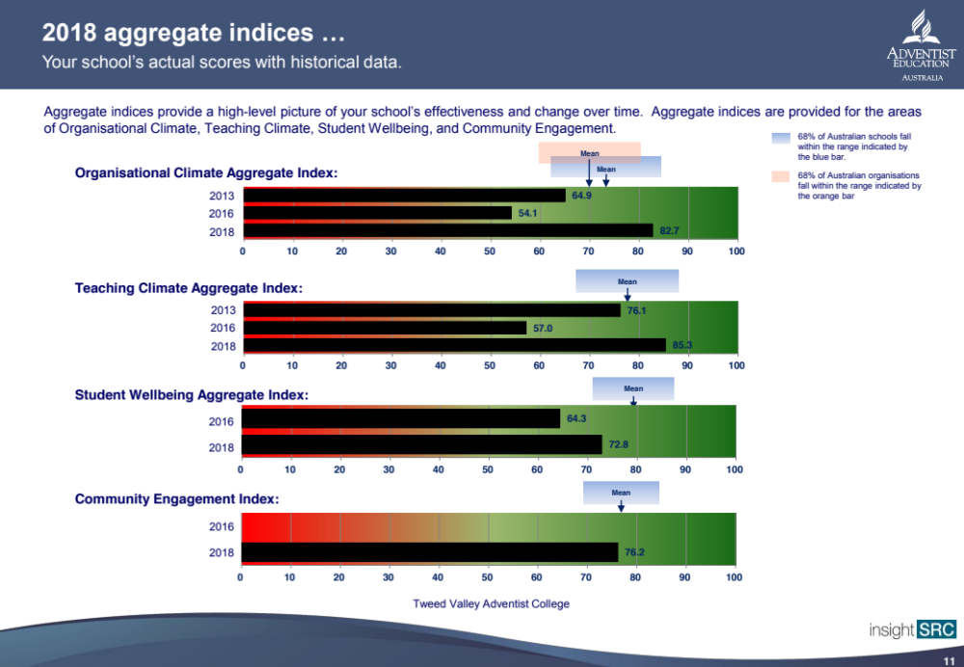

This table provides survey data over four key areas for 2013, 2016 and 2018. It is encouraging to see that 2018 produced a marked improvement in all areas. Note that there is no 2013 data available for Student Wellbeing or 2013 and 2016 data available for Community Engagement.

Table 4

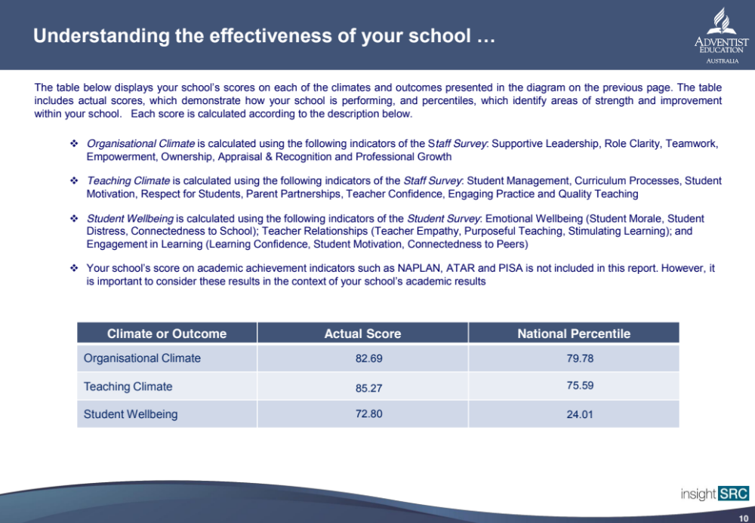

This table shows pleasing results in the areas of Organisation Climate, Teaching Climate and Student Wellbeing. Note that in all three areas the TVAC score was higher than the National Percentile and the Student Wellbeing is considerably higher.

The Council would like to congratulation the TVAC Staff for their hard work and a very successful year.

Pr Cranville Tooley
School Advisory Council Chairman

2 Contextual information about the school (including information about National Partnerships and /or Improving Teacher Quality if applicable)
Tweed Valley Adventist College (TVAC) is a co-educational Pre-Kindy to Year 12 school owned and operated by the Seventh-day Adventist Schools (NNSW) Ltd. TVAC has operated on its current site in Murwillumbah for more than 40 years with 209 students Kindergarten to Year 12 (August 2017 census), 10 Pre-Kindy students and 33 staff (in full time and part time positions).
TVAC is a low SES, low fee school with a developed niche emphasis on pastoral care.

Murwillumbah has a population of 6,342 but services a region of more than 10,000 people. Economic indicators reveal that it is a lower socio economic community and this is reflected in the school SES of 93. Unemployment is 8.9%. (4.5% NSW). The median individual income is $419.00 per week and the median household income is $770.00 per week, 25% lower than the NSW AVG and well short of the national average weekly income of $1,145.70.

52% of people on Newstart Allowance received benefits for more than 12 months and only 65.6% of households in our region have broadband Internet connection. We have a number of families who do not have internet at home and this makes it challenging to deliver educational options in a rapidly changing technological society. We are hoping the NBN rollout will improve this situation.

Murwillumbah has an ageing population with the average age of 43 years of age, which is seven years higher than the national average. Only 10.8% of residents have obtained a degree which is well below the national average of over 25%.
The following statistics from http://murwillumbah.localstats.com.au provide an overview of the community.
- 83.9% of people living in Murwillumbah were born in Australia. The other top responses for country of birth were 3.3% England, 1.8% New Zealand, 0.9% India, 0.5% Scotland, 0.5% Netherlands, 0.3% Germany, 0.3% United States of America, 0.3% Ireland, 0.3% South Africa, 0.3% Northern America, 0.2% Italy, 0.2% Philippines, 0.2% Canada, 0.1% Papua New Guinea.
- 92.4% of people living in Murwillumbah speak English only. The other top languages spoken are 1.0% Punjabi, 0.6% Other, 0.4% German, 0.3% Spanish, 0.3% Dutch, 0.3% Italian, 0.1% Bengali, 0.1% Mandarin.
- The religious makeup of Murwillumbah is 25.5% Catholic, 21.7% No religion, 21.1% Anglican, 8.3% Religious affiliation not stated, 4.9% Presbyterian and Reformed, 3.7% Uniting Church, 2.8% Christian, 1.9% Hinduism, 1.8% Seventh-day Adventist, 1.6% Other Religious Groups.
- 43.6% of people are married, 30.2% have never married and 11.8% are divorced and 3.7% are separated. There are 544 widowed people living in Murwillumbah.
- 49.9% of the people living in Murwillumbah over the age of 15 and who identify as being in the labour force are employed full time, 34.6% are working on a part time basis. Murwillumbah has an unemployment rate of 8.9%, which is considerably higher than the national average of 5.7%.
- The main occupations of people living in Murwillumbah are 16.5% Professionals, 15.2% Technicians & trades workers, 13.6% Labourers, 12.3% Sales workers, 12.3% Clerical & administrative workers, 11.9% Community & personal service workers, 9.3% Managers, 7.5% Machinery operators & drivers, 1.5% Occupation inadequately described/ Not stated.
- The main industries people from Murwillumbah work in are 15.5% Health care and social assistance, 13.7% Retail trade, 8.2% Education and training, 8.1% Accommodation and food services, 8.0% Construction, 7.9% Public administration and safety, 6.1% Manufacturing, 5.1% Transport, postal and warehousing, 4.5% Professional, scientific and technical services.
- 35.9% of homes are fully owned, and 29.2% are in the process of being purchased by home loan mortgage. 30.6% of homes are rented.
- The median rent in Murwillumbah is $235 per week and the median mortgage repayment is $1709 per month.

These statistics combine to produce a rich diversity of people in our community and our school enjoys the benefits of this diversity.

* Tweed Valley Adventist College does not receive National Partnerships Funding.

3 Student performance in National and State-wide tests and examinations

3.1 Student outcomes in standardised national literacy and numeracy testing

Literacy
Language Conventions includes Reading, Writing, Spelling, Grammar and Punctuation.

Reading
Year | % below national minimum standard | % at national minimum standard | % above national minimum standard
Year 3 | 0 | 6.6 | 93.4
Year 5 | 0 | 11.1 | 88.9
Year 7 | 0 | 12.5 | 87.5
Year 9 | 6.7 | 13.2 | 79.8

Writing
Year | % below national minimum standard | % at national minimum standard | % above national minimum standard
Year 3 | 0 | 0 | 100
Year 5 | 25 | 0 | 75
Year 7 | 12.7 | 17.4 | 69.5
Year 9 | 6.7 | 33.3 | 605.9

Spelling
Year | % below national minimum standard | % at national minimum standard | % above national minimum standard
Year 3 | 0 | 0 | 100
Year 5 | 0 | 11.1 | 88.9
Year 7 | 8.78 | 13 | 78.3
Year 9 | 20 | 20 | 60

Grammar and Punctuation
Year | % below national minimum standard | % at national minimum standard | % above national minimum standard
Year 3 | 5.9 | 0 | 94.1
Year 5 | 0 | 11.1 | 88.9
Year 7 | 8.7 | 8.7 | 82.6
Year 9 | 13.3 | 13.3 | 73.4

Interpretative Comments

Reading
Primary

Year 3 and Year 5 - We are very proud of these results with 0% below national minimum standards. We have placed lots of emphasis on quality teaching practices with the inclusion of explicit teaching of reading comprehension through modelled, shared and guided reading. We will be focussing on getting all of our students above national minimum standards with further intervention and focus on phonics in early years to raise competency early.

Secondary
We aim to have all students reading at or above the national standard. One student in Year 9 failed to meet the benchmark and this is most probably due to external pressures.

Writing
Primary

Year 3 - We are very proud of the Year 3 writing results with all of the students above National Minimum Standards. This is a result of our quality Early Years programs that focus on early Literacy skills. It is our Goal to bring this up further with the introduction of The Literacy Code and the Seven Steps to Writing Success Program.
Year 5 - These are average results that clearly show room for improvement. There was a big difference in results to Year 3 so further analysis of our writing program will be done. During 2016 and 2017 the program focused on genre writing. It is our Goal to bring this up further with the introduction Seven Steps to Writing Success Program.
Secondary
Our Year 7 and 9 writing results were disappointing in 2017 and as a consequence we have trained Sue Redsell in NAPLAN marking. We are looking to embed the NAPLAN marking style into our units. We plan on prioritising this before next year’s test.
Spelling
Primary

Year 3 and Year 5 - We are very proud of these results. We had been using Sound Waves program that was a developmental approach to teaching spelling. We aim to further increase these results with the introduction of the Spelling Sensations Program that takes on a differentiated, developmental and explicit teaching approach. Through our own school testing and results it has already shown improvement.

Secondary
Two students in Year 7 and three Year 9 were below the minimum standard and the English teachers have now implemented spelling tests into their units.

Grammar and Punctuation.
Primary

Year 3 – We are pleased with these results and are looking for ways to strengthen the 5.9% of students who are below national minimum standard. We have introduced The Literacy Code from Pre Kindy which will aim to improve literacy across the board.

Year 5 - These are an improvement from 2017 results. We have been reviewing current programs and allocated extra time to the explicit teaching of Grammar and Punctuation. These in now the emphasis in the transfer to sentence structure in writing rather than in isolation.
Secondary
Two year 7 and two year 9 students were below the minimum standard. Both Year 9 students have left the school. We now have a regular system of working on Grammar and Punctuation, which we hope will improve these results in future tests.

Numeracy
Numeracy incorporates Number and Data, Patterns and Algebra, Measurement Space and Geometry.
Year | % below national minimum standard | % at national minimum standard | % above national minimum standard
Year 3 | 0 | 5.9 | 94.1
Year 5 | 0 | 11.1 | 88.9
Year 7 | 0 | 16.7 | 83.3
Year 9 | 0 | 33.3 | 66.7

Interpretative Comments
Primary
Year 3 and Year 5 - These results are positive but still leave room for improvement and a review of current programs. We have moved to Envision Maths Program which places a larger emphasis on early number sense.
Secondary
While it is noteworthy that all of our students are above the minimum standard we will continue to work towards our goal of having all students reach our goal of 85% above the minimum standard through increased exposure to problem solving experiences and making our work as authentic as possible.

3.2 Record of School Achievement
Item | Students
Number of Students studying in Year 10 | 17
Number of ROSAs issued by NESA in 2018 | 0

3.3 Results of the Higher School Certificate Examination 2018

Comparison of 2018 results compared to the state
Subject | No of students |  | Performance band achievement by number and/or %
Subject | No of students |  | Band  6 | Band  5 | Band  4 | Band  3 | Band  2 | Band  1
English Advanced | 4 | School |  |  |  | 75 | 25
English Advanced | 4 | State | 14 | 49 | 28 | 8 | 1 | 0
English Standard | 5 | School |  |  |  | 40 | 20 | 20
English Standard | 5 | State | 1 | 14 | 35 | 34 | 11 | 3
Industrial Technology | 7 | School |  | 43 | 29 | 29
Industrial Technology | 7 | State | 6 | 16 | 26 | 28 | 16 | 8
Legal Studies | 7 | School |  |  | 43 | 14 | 29 | 14
Legal Studies | 7 | State | 12 | 32 | 28 | 13 | 10 | 4
Mathematics General 2 | 5 | School |  |  | 20 | 40 | 40
Mathematics General 2 | 5 | State | 7 | 20 | 26 | 26 | 15 | 5
Mathematics | 4 | School |  |  |  | 75 |  | 25
Mathematics | 4 | State | 22 | 29 | 26 | 15 | 5 | 2
Modern History | 9 | School |  |  | 11 | 78 |  | 11
Modern History | 9 | State | 10 | 31 | 29 | 14 | 8 | 6
Studies of Religion I | 18 | School |  |  |  | 39 | 56 | 6
Studies of Religion I | 18 | State | 9 | 28 | 34 | 23 | 6 | 1
Studies of Religion II | 7 | School |  |  | 71 | 29
Studies of Religion II | 7 | State | 7 | 34 | 30 | 20 | 7 | 2

Interpretative comments for Higher School Certificate results

Comparison of 2018 HSC results as a trend over time

Subject | No of students |  | Performance band achievement by number and/or %
Subject | No of students |  | Band  6 | Band  5 | Band  4 | Band  3 | Band  2 | Band  1
English Advanced | 4 | 2018 |  |  |  | 75 | 25
English Advanced | 11 | 2017 |  |  | 73 | 27
English Advanced | 7 | 2016 |  | 29 | 71
English Standard | 5 | 2018 |  |  |  | 40 | 40 | 20
English Standard | 4 | 2017 |  |  |  | 50 | 25 | 25
English Standard | 9 | 2016 |  |  | 22 | 67 | 11
Industrial Technology | 7 | 2018 |  | 43 | 29 | 29
Industrial Technology | - | 2017
Industrial Technology | 10 | 2016 | 20 | 30 | 30 | 30
Legal Studies |  | 2018 |  |  | 43 | 14 | 29 | 14
Legal Studies |  | 2017
Legal Studies |  | 2016 |  | 60 | 20 | 20
Mathematics General 2 | 5 | 2018 |  |  | 20 | 40 | 40
Mathematics General 2 | 9 | 2017 |  |  | 33 | 33 | 22 | 11
Mathematics General 2 | 12 | 2016 |  | 17 | 58 | 25
Mathematics | 4 | 2018 |  |  |  | 75 |  | 25
Mathematics | 6 | 2017 |  |  | 50 | 33 | 17
Mathematics | 2 | 2016 |  | 50 | 50
Modern History | 9 | 2018 |  |  | 11 | 78 |  | 11
Modern History | - | 2017
Modern History | - | 2016
 |  | 2018
 |  | 2017
 |  | 2016
Studies of Religion I | 18 | 2018 |  |  |  | 39 | 56 | 6
Studies of Religion I | - | 2017
Studies of Religion I | 18 | 2016 | 6 | 28 | 17 | 28 | 6 | 17
Studies of Religion II | 7 | 2018 |  |  | 71 | 29
Studies of Religion II | - | 2017
Studies of Religion II | 15 | 2016 | 7 | 20 | 40 | 33 | 0 | 0

Interpretative comments for Higher School Certificate result trends over time
These results are not as strong as in previous years. It is reflective of a less academic cohort.

4 Senior secondary outcomes
Percentage of students in Year 12 undertaking vocational or trade training:

Percentage of students in Year 12 attaining a Year 12 certificate or equivalent VET qualification:

5 Professional learning and teacher standards

5.1 Professional Learning
Areas of professional learning | Teachers  (number or group)
Aboriginal and Torres Strait Island Education | 3
Classroom Practice | Group
English | 9
HSIE | 9
Mathematics | 3
Performance and Professional Development | Group
Special Education | 3
Student Wellbeing | 9
Teacher Accreditation | 6
Workplace Management | 3
CPR Course & First Aid | Group
Workplace Induction | 3
Bronze Medallion | Group
Technology – ICT, Wood Tech | 4

Total Staff PD experiences: | 14
Average cost per teacher for professional learning: | $585.66 pp

5.2 Teacher Accreditation Status
Accreditation Level of Teachers | Numbers of teachers
(i) Conditional | 2
(ii) Provisional | 3
(iii) Proficient or higher | 17
 | 22

6 Workforce composition (comment on Indigenous staff)
There are six teachers in the primary school – all are female
There are sixteen teachers in the secondary school – eight male, eight female
There are no teachers with an indigenous heritage
There are two fulltime chaplains – one male and one female
There are a number of other ancillary staff who contribute to our safe and engaging learning environment

7 Student attendance rate and non-attendance

7.1 Average Year Level Attendance
Year Level | Average Attendance (%)
Kindergarten | 77.8
Year 1 | 93.1
Year 2 | 92.6
Year 3 | 93.2
Year 4 | 92.5
Year 5 | 88.5
Year 6 | 92.6
Year 7 | 88.2
Year 8 | 90.7
Year 9 | 88.3
Year 10 | 88.2
Year 11 | 92.4
Year 12 | 89.6
Total school attendance average | 89.8

7.2 Management of non-attendance
In New South Wales, ‘compulsory school-age’ means that all children from six years of age are legally required to be enrolled at and attending school or to be registered for home schooling. After they complete Year 10, and until they turn 17 years of age, students then have the following options. They may also be in:

• full-time further education and training (e.g. TAFE, traineeship, apprenticeship);
• full-time, paid employment of an average of 25 hours per week; or
• a combination of both of the above.

Parents or carers are responsible for making sure that their children comply with these legal requirements. Schools support parents by monitoring student attendance and helping to address attendance issues when they emerge.

At Tweed Valley Adventist College Teachers mark rolls electronically via SEQTA Learning Management System.
An absentee SMS is sent to parents by 10:30am if the child is marked absent on the morning roll.

Students arriving late or leaving early are registered on the roll via Student Services and provided with a late or early leave slip.

The electronic attendance register on the database is coordinated by the College Administration Office.

Students are required to bring a note the next day (or day of next attendance) explaining the absence from school. If this is not received, an absentee follow up letter is posted to parents.

A medical certificate may be required if the absence coincides with an assessment task in Years 10‐ 12 or if the absence is protracted in nature.

Parents are contacted if there is a pattern of non‐attendances or lateness.
Chronic lateness and absences are followed up and reported to the AIS Student Welfare advisor and attendance plans put in place through interviews with parents, student, and Head of School.

All absence notes are filed in the College Administration Office Strong Room and archived for the appropriate period.

7.3 Retention from Year 10 to Year 12 (where relevant)
Percentage retention rate: 45%

8 Post School Destinations (secondary schools only)
(report on the destination of all students 17 and over who left school during 2018)
- Three are attending university
- Two are having a ‘Gap Year’
- One is doing a mechanics apprenticeship
- One is attending a Bible College for a ‘Gap Year’
- One is seeking employment
- One is working in construction

9 Enrolment Policies and characteristics of the student body

Applications
Applications for enrolment may be made at any time by the parent/carer(s) of students to commence at a nominated SDA school.

Students enrolling in K at the school for the first time will be at least 5 years of age on or before 31 July of the enrolling year. Students enrolling in Pre Kindergarten classes will be at least 4 years of age on or before 31 July of the enrolling year.

Please Note: Individual SDA schools may vary in the starting age of students. School commenced on 30 January.

Immunisation Requirements
All schools are required to request an immunisation certificate at enrolment.

The school will then:
- record each child’s immunisation status in a register and retain copies of approved immunisation certificates for a period of three years after the child has ceased to attend the school;
- provide a copy of a child’s immunisation certificate to a school that the child has transferred to (on request);
- notify the public health unit if an enrolled child has a vaccine preventable disease, or if they reasonably believe that an unimmunised enrolled child has come into contact with someone who has a vaccine preventable disease;
- exclude unimmunised children at risk of contracting a disease from attending school on the direction of a public health officer.

Processing Applications
- The school will base any decision about offering a place to a student on:
- Family Relationship with the school:
  - the applicant coming from a Seventh-day Adventist family;
  - sibling of a current or ex-student;
  - whether they hold attitudes, values and priorities that are compatible with the school ethos.
- The Student:
  - the contribution that the student may make to the school, including the co-curricular activities;
  - any special needs or abilities of the student;
  - the student's reports from previous schools.
- Other Considerations:
  - order of receipt - when the application to enrol is received by the school.

- The school will meet with parent/caregiver(s) of the students before offering a place.

- The school has an absolute discretion in determining the weight of each of the factors it takes into account in determining whether to offer a place for the student.

- Continued enrolment at the school is dependent upon the student making satisfactory academic progress, attending consistently, and the student and the parent/carer(s) observing all behavioural codes of conduct, payment of fees and other requirements of the school which are applicable from time to time.

Composition/characteristics of the student population

10 School Policies

Student Welfare Policy

Summary of policies for Student Welfare
- Rationale
All children have a right to feel safe and supported in their school environment. As school staff, we have a legal and moral responsibility to ensure programs and procedures are in place to provide support and pastoral care for students as well as providing for their physical safety at school.

- Aim
To ensure that every child's need for support and safety is maintained.

- Implementation
This school will abide by the legislation pertinent to the provision of a safe and supportive environment. This includes:
- making sure buildings and facilities are secure and evacuation procedures are in place;
- having in place a rigorous supervision protocol including a risk management process for onsite and off-site activities;
- having in place codes of conduct that will ensure the rights and responsibilities of students and staff, the application of a behaviour management system (including anti-bullying), a student leadership system, and the management and reporting of serious incidents;
- a process for receiving complaints/grievances from students, and/or parents/guardians;
- a pastoral care plan which gives students access to counselling, provision of support for special needs students, a scheme for the distribution of medication, and a serious incident response mechanism; and
- guidelines for formal and informal communication with all stakeholders.

Location of the Student Welfare policy (Safe and Supportive Environment Policy) is found on the school’s intranet. To obtain a copy please ask at the front office.

There have been no changes made to this policy during 2018.

Discipline Policy
- Rationale
All students have a right to a discipline system (including but not limited to the suspension, expulsion and exclusion of students) that is based on procedural fairness and expressly prohibits the use or corporal punishment or the implicit sanctioning of such. As school staff, we have a legal and moral responsibility to ensure that a fair and redemptive discipline system is in place and well understood by students and staff.

- Aim
To ensure that a procedurally fair discipline system is in place.

- Implementation
This school will abide by the legislation pertinent to the provision of a discipline system (including but not limited to the suspension, expulsion and exclusion of students) that is based on the principles of procedural fairness. This includes the right of the student to:
- know the allegation and any other information related to it;
- know the process by which the matter will be considered;
- make a response to the allegation;
- know how to have any process or decision reconsidered;
- expect impartiality in the investigation and the decision making; and
- an unbiased decision-maker.

This school expressly prohibits corporal punishment in any form or the implicit sanctioning of such.

Location of the Discipline policy (Student Management Policy) is found on the school’s intranet. To obtain a copy please ask at the front office.

The following sentence has been added to this policy during 2018

‘This school expressly prohibits corporal punishment in any form or the implicit sanctioning of such.’

Anti-Bullying Policy
Safe and Supportive environment at TVAC.

TVAC used to have a separate bullying policy, however, it was found to be confusing for students and teachers trying to delineate whether the bullying behaviour was to be handled by the Discipline Policy or the Bullying Policy. Therefore, the Bullying Policy was incorporated into the Discipline Policy where a clear description of bullying behaviour is listed in levels with subsequent consequences.

Location of the full text of the policy

The full text of the school’s Discipline Policy is provided to all families upon enrolment can be accessed by request from the principal.

Changes made to the Policy during 2018

No changes were made to this policy in 2018.

Complaints and Grievances Policy
- Purpose
This Guideline is intended to ensure that com plaints are handled fairly, efficiently and effectively. The complaints management system is intended to:
- enable schools and the Company to respond to issues raised by people making complaints in a timely way; and
- provide information that can be used to deliver quality improvements in schools, systems, practices, procedures and complaint handling.
This document provides the key principles and concepts of the complaints management system for both staff and parents and others who wish to make a complaint.

- Company Commitment
The company expects staff at all levels to be committed to fair, effective and efficient complaint handling.

  - Director
The Director is committed to promoting a culture that values complaints and their effective resolution by:
- providing adequate support and direction to key staff responsible for handling complaints;
- regularly reviewing reports about complaint trends and issues arising from complaints;
- encouraging staff to make recommendations for system improvements;
- supporting recommendations for system improvements arising from analysis of complaint data.

  - Principal
The Principal is responsible for complaint handling in each school and is committed to establishing and managing the complaints management system by:
- providing regular reports to the Director on issues arising from complaint handling work;
- ensuring recommendations arising out of complaint data analysis are canvassed with the Director and implemented where appropriate;
- training and empowering staff to resolve complaints promptly and in accordance with company policies and guidelines.
- encouraging staff to provide suggestions on ways to improve the company's complaints management system.

  - Staff
Staff whose duties include complaint handling are expected to be committed to demonstrating exemplary complaint handling practices by:
- treating all people with respect, including people who make complaints;
- complying with the Company Complaints Handling Guideline;
- keeping informed about best practice in complaint handling;
- assisting people who wish to make complaints to access the complaints handling guideline;
- assisting those handling complaints to resolve matters promptly;
- providing feedback to their principal/director on issues arising from complaints; and
- implementing changes arising from individual complaints and from the analysis and evaluation of complaint data.

- Guiding Principles

Facilitating Complaints

People focus
The company is committed to seeking and receiving feedback and complaints about practices,
procedures and complaint handling at schools and/or the company level.

Any concerns raised in feedback or complaints will be dealt with within a reasonable timeframe.

People making complaints will be:
- provided with information about the complaints handling process;
- listened to, treated with respect by staff and actively involved in the complaint process where practicable and appropriate; and
- provided with reasons for decision/s and any options for redress or review.

No detriment to people making complaints
All reasonable steps will be taken to ensure that people making complaints are not adversely affected because a complaint has been made by them or on their behalf.

Anonymous complaints
Anonymous complaints will be accepted and there will be an investigation of the issues raised where there is enough relevant information provided, including the identity of the school or office to which the complaint relates.

Visibility and transparency
Information about how and where complaints may be made will be readily available and publicised on school websites.

Accessibility
The company is committed to ensuring that its complaints management process is easily understood and accessible to everyone, particularly people who may require assistance, for example, people for whom English is not their first language.

If a person prefers or needs another person to assist them in the making and/or resolution of their complaint, the school or company will communicate with them through their representative if this is their wish. Anyone may represent a person wishing to make a complaint, with their consent.

Respond to Complaints

Early resolution
Where possible, complaints will be resolved at first contact with the particular school or, in the case of complaints about the company, first contact with the director.

Responsiveness
Complaints will be assessed and prioritised in accordance with the urgency and/or seriousness of the issues raised. If a matter concerns an immediate risk to safety or security the response will be immediate and will be escalated appropriately.

The company is committed to managing people's expectations and will inform them as soon as possible, of the following:
- the complaints process;
- the expected timeframes for actions;
- the progress of the complaint and reasons for any delay; and
- their likely involvement in the process.
The school or company will advise people as soon as practicable when it is unable to deal with any part of their complaint.

Objectivity and fairness
Each complaint will be addressed with integrity and in an equitable, objective and unbiased manner. Each complaint will be assessed on its merits.
Conflicts of interests, whether actual or perceived, will be managed responsibly. In particular, internal reviews of how a complaint was managed will be conducted by a person other than the original decision maker.

Confidentiality
The identity of people making complaints will be protected where this is practical and appropriate.

Personal information that identifies individuals will only be disclosed or used by the company as permitted under privacy legislation.

Manage the Parties to a Complaint

Empowerment of staff
All staff managing complaints are empowered to implement the complaints guideline as relevant to their role and responsibilities. Staff are empowered to resolve complaints promptly and with as little formality as possible. Staff are encouraged to provide feedback on the effectiveness of this complaints management process.

Managing unreasonable conduct by people making complaints
Schools and the company are committed to being accessible and responsive to all people who approach them with feedback or complaints.

When people behave unreasonably in their dealings with either a school or the company, conduct can significantly affect the progress and efficiency of the school or company's work. As a result, any conduct that negatively and unreasonably affects a school or the company will be proactively and decisively managed by staff.

- Complaint Management System

Stages of Managing a Complaint
When responding to complaints, staff should act in accordance with this guideline. There are five key stages in the complaint management system:
- Receipt of complaints;
- Acknowledgement of complaints;
- Initial assessment and addressing of complaints;
- Providing reasons for decisions; and
- Closing the complaint, records keeping, redress and review.

Receipt of Complaints
Unless the complaint has been resolved at first point of contact, it will be recorded as a complaint together with its supporting information. Initially verbal complaints will be accepted but with serious complaints the person making the complaint may subsequently be asked to set out their complaint in writing.

The record of the complaint will identify:
- the contact information of the person making the complaint;
- issues raised by the person making the complaint;
- the school or company to which the complaint relates;
- the outcome/s sought;
- any other information required to properly respond to the matter; and
- any additional support the person making the complaint requires.

Acknowledgement of Complaints
The receipt of each complaint will be acknowledged promptly and usually within 10 working days.

Consideration will be given to the most appropriate medium for communicating with the person making a complaint, taking into account the needs of the school or the company and the expressed views of the person making the complaint.

Initial Assessment and Addressing of Complaints
After acknowledging receipt of the complaint, the staff member handling the complaint will confirm whether the issue/s raised in the complaint is/are within the school’s or company's control. The outcome/s sought by the person making a complaint will be considered and, where there is more than one issue raised, there will be a determination whether each issue needs to be separately addressed.

When determining how a complaint will be managed, the issues raised will be assessed against the following criteria:
- severity;
- complexity;
- health and safety implications;
- impact on the individual or wider school community; and
- potential to escalate.

Addressing complaints
The methodology for addressing the complaint may include:
- working with the person making the complaint to see how the issues can be appropriately addressed;
- making inquiries with the person or area that is the subject of the complaint; and/or
- conducting an investigation into the issues raised in the complaint.

The nature and scope of any action taken will depend on a number of factors including:
- the circumstances of each case;
- any statutory requirements;
- the issue/s complained about;
- the parties involved; and
- the likely outcome.

- Providing Reasons for Decisions

Following consideration of the complaint and any investigation into the issues raised, the person making the complaint will be contacted in a timely manner and advised of:
- the outcome of the complaint and any action that was taken arising out of the complaint so far as permitted under privacy legislation;
- the reasons for any decisions that have been made; and
- any remedy or resolution that has been offered.

- Closing the Complaint, Record Keeping, Redress and Review

At the time of closing the complaint a record will be made of the following:
- steps taken to address the complaint;
- the outcome of the complaint; and
- any undertakings or follow up action required.

- Three Levels of Complaint Handling

Where possible, complaints will be resolved by staff at the appropriate school level. Staff will be adequately equipped to respond to complaints, including being given appropriate authority, training and supervision.

Where early resolution of a complaint is not possible, however, due to the complexity of the issues raised, dissatisfaction with the complaint outcome or how the complaint was dealt with, the complaint may be escalated to the director level. This second level of complaint handling will provide for the following internal mechanisms:
- assessment and possible investigation of the complaint and decision/s already made, and/or
- facilitated resolution (where a person not connected with the complaint reviews the matter and attempts to find an outcome acceptable to the relevant parties).

Where a person making a complaint is dissatisfied with the outcome of the director's review of their complaint they may seek a further review from the Chair of the Board of Directors. In some instances the Chair of the Board of Directors may engage a third party to review a matter and provide a report.

- Accountability and Learning

Analysis and Evaluation of Complaints
Complaints are recorded in a systematic way so that information can be easily retrieved for reporting and analysis.

Regular reports will be run on:
- the number of complaints received;
- the outcome of complaints;
- issues arising from complaints;
- systemic issues identified; and
- the number of requests received for internal and/or external review of complaint handling.
Regular analysis of these reports will be undertaken to monitor trends, measure the quality of service and make improvements.

Both reports and their analysis will be provided to the Director of Education for review.

Monitoring of the Complaint Management System
The complaints management system will be monitored to:
- ensure its suitability for responding to and resolving complaints; and
- identify and correct deficiencies in the operation of the system.

Continuous Improvement
The Company is committed to improving the effectiveness and efficiency of its complaints management system. To this end, the company will:
- support the making and appropriate resolution of complaints;
- implement best practices in complaint handling;
- regularly review the complaints management system and complaint data; and
- implement appropriate system changes arising out of analysis of complaints data and
- continual monitoring of the system.

This is the full text of the Complaints and Grievances policy (Complaints Handling Guideline) and is found on the school’s intranet. To obtain a copy please ask at the front office.

This is a new Policy introduced during 2018.

11 School determined improvement targets

Priority Areas for Improvement for 2019 (Schools in National Partnerships should include items from their school plan and come from the QAS Rolling School Improvement Plan)

1.3 Pastoral Care

2.2 Curriculum and Assessment

2.4 Student Learning and Engagement

Achievement of Priority Areas listed for improvement in the 2018 report (Schools in National Partnerships should include achievements of items from their school plan and come from the improvements listed in your last Annual Report)

In 2018 the areas of School Improvement which were reviewed as part of the QAS included:

Special Character
Human Resources
Wider Community
Professional Partnerships

No specific goals from this review have been added to the improvement plan. However organic improvements continue to happen, specifically in the area of special character.

Adventist Identity - Whole School Focus
Special Character around the school is more visible with an increase in the number of banners to promoting the ethos of the school. In 2018 more promotional posters and signs were installed - mission related quotes from E.White placed in our admin reception and other strategic locations as a visual reminder of our purpose as educators.

Learning and Teaching Improvements - Secondary Focus
In 2018 Secondary School improvement continued to focus on Student Learning and Engagement; improvement goals related to Professional Learning with a professional development focus on Assessment (specifically based off the Stronger HSC Standards requirements) as well as student Assessment and Reporting. More PD planned on improving assessment practices in 2019 with both Primary and Secondary teachers attending the Project Based Learning workshop.

Learning and Teaching Improvements - Primary Focus
In 2018 the Primary School continued to implement a new Literacy Program in three areas: Phonics, Spelling and Reading Comprehension. This plan was devised based on the drop of NAPLAN scores over the past couple of years and the inconsistencies of programs. These new programs were a phased implementation with Semester 2, 2017 being a trial and learning time and 2018 being full implementation.
The Phonics/DD Code has engaged the students and allowed them to surpass the expectations of Kindy results with some children achieving 6-12 months ahead of year level expectation. The Reading Comprehension Program saw a consistency in common language across Kindy to Year 6 and the PAT Reading Testing showed positive results with our primary college scores being higher than Australian norms especially for Year 2.
Our new Spelling Sensations program offers a differentiated learning program and we now have increased engagement and success as gaps in learning are being identified and filled. In all areas, teachers are data driven and are engaged in implementing these new programs as they are seeing the results in their students.

12 Initiatives promoting respect and responsibility
TVAC teachers and staff promote and model a culture of respect and responsibility. It has been observed that these two important attributes are diminishing in our society and we are committed to instilling these qualities in our students to increase their potential in life. The following initiatives were in place in 2018.

A secondary school camps program:

- Year 7 Midginbill Hill – high school orientation and team work (3 nights)
- Year 8 Mentoring Camp (separate boys and girls) (4 nights)
- Year 9 Resilience Camp – Emu Gully (4 nights)
- Year 10 Outdoor Ed. Camp – Fraser Island (8 nights)
- Year 11 Vanuatu Service Expedition (2 weeks)

Spiritual Emphasis Activities

Students have participated in a two Week of Spiritual Emphasis (WOSE) programs where for one period per day over the course of a week, students engaged in a chapel program designed to build self-esteem and confidence in the context of a relationship with God.

Weekly Chapel program

Students participate in a weekly Chapel program which affirms resilience and participation with their community through a range of speakers presenting on topics as diverse as addictive behaviours relating to drugs and alcohol, community living and standards, spiritual development, interpersonal relationships, environmental awareness and personal responsibility. Chapel presenters include a range of school and community speakers.

Pastoral Care Program
(Chaplaincy & Counselling)

Students have access to a school chaplain, which within the context of an active Christian school environment is most welcome by many of the students and their families as a way of providing appropriate direction and support across a range of respect and responsibility related issues.

Students have access to a qualified counsellor at the school to assist them to negotiate the various stages of personal development and the dilemmas which at times confront both children and young people.

The pastoral care program at TVAC is not restricted to the chaplaincy and counselling team. All teaching staff are encouraged to develop mentoring relationships with their students as a way of providing that link between relationships and learning which is so often the vital key to students achieving success and happiness at school.

Regular School Program

The school is committed to nurturing the whole person. All learning activities at TVAC are designed to develop the intellectual, emotional, spiritual, social and physical capabilities of each student. The aim of TVAC is to develop students with a strong level of resilience who, through integrity developed over their time at the school, are committed to serving their community.

Students attending TVAC are supported through a whole of school structure which encourages students to attain their individual best through traditional Science, Mathematics, English, Technology, Music, PDHPE and Art programs together with learning support, an ICT program which allows all students at the school access to three computer laboratories (Mac, PC and Google Chrome) as required, and a comprehensive literacy and numeracy program.

13 Parent, student and teacher satisfaction

14 Summary financial information
The schools company will complete this section for all SDA schools.

Income
Income Sources | Percentage of Total Income
Fees and private income | 31.91%
State recurrent grants | 11.92%
Commonwealth recurrent grants | 50.85%
Other Government grants | 0.13%
Government capital grants | 3.00%
Other capital income | 2.18%

Expenditure
Expenditure Costs | Percentage of Total Expenditure
Salaries, allowance and related expenses | 56.82%
Non-salary expenses | 26.67%
Classroom expenditure | 3.61%
Capital expenditure | 12.90%

15 Public disclosure of educational and financial performance
The 2018 Annual report will be published on the College’s website and available on request from the College office.

SECTION 2

CHECKLIST

Commonwealth legislation (Schools Assistance Act 2008) includes the following requirements not listed as part of NESA requirements for registration and accreditation.

Please tick that your school complies with the following. (please delete the least applicable box)

☑ Participates in National Student Assessments – NAPLAN

☑ Provides national reports on the outcomes of schooling

☑ Provides individual school information on performance

☑ Passes on the NAPLAN reporting to parents showing student results against key national information

☑ Annually reports on school performance information and makes the report publicly available

☑ Implements the National Curriculum as it becomes available

☑ Has an annual certificate of financial accountability from a qualified accountant

☑ Annually reports on each program of financial assistance provided under this Act

☑ Participates in program evaluations

